Puerto Rico Medicaid Program
Medicaid Eligibility and Enrollment System
Request for Information (RFI)

September 29, 2023

THIS IS A REQUEST FOR INFORMATION (RFI) ONLY THIS IS NOT A FORMAL BID SOLICITATION.
NO AWARD WILL RESULT FROM THIS RFI.

Table of Contents
1. Executive Summary 3
1.1 Purpose of the RFI 3
1.2 PRMP Background 3
2. Background and Overview of Existing E&E System 4
2.1 Background 4
2.2 Current E&E Landscape 5
3. Requested Information 6
4. Timeline and Response Instructions 7
4.1 Timeline 7
4.2 Submission Requirements 7
5. Terms and Conditions 8

Tables of Figures
Figure 1: METIDI3G High Level Architecture 5
Figure 2: MEDITI3G Context Diagram 5

1. Executive Summary

1.1 Purpose of the RFI
The Puerto Rico Department of Health (PRDoH) oversees the Puerto Rico Medicaid Program (PRMP). PRMP is issuing this RFI to learn from the Medicaid Eligibility and Enrollment (E&E) vendor community about the current vendor landscape and recent improvements in software and related services to potentially inform future procurements.
The Commonwealth of Puerto Rico (Commonwealth) appreciates and welcomes responses to this RFI and your willingness to support our efforts to provide an exceptional E&E solution for our members and constituents.

1.2 PRMP Background
PRDoH is the State Medicaid Agency (SMA) within the Commonwealth of Puerto Rico. Within PRDoH, PRMP is responsible for the management of the Medicaid Program and the Puerto Rico Medicaid Enterprise System (PRMES), both of which are multi-vendor, multi-agency environments. The Puerto Rico Health Insurance Administration Act (PRHIA) created the Administración de Seguros de Salud (ASES), which has a Memorandum of Understanding (MOU) with PRMP and is responsible for contracting with, and monitoring services provided by, the Managed Care Organizations (MCOs) and other carriers.
The PRMES encompasses the Puerto Rico Medicaid Management Information System (PRMMIS), Provider Enrollment Portal (PEP), E&E system known as Medicaid Information Technology Initiative Third Generation (MEDITI3G), the Commonwealth’s Health Information Exchange (HIE), and the staff, vendors, and interfaces supporting the PRMES.
Approximately half of Puerto Rico's million residents are enrolled in Puerto Rico’s Medicaid program (1.6 million Medicaid beneficiaries).

2. Background and Overview of Existing E&E System
Section 2, below, provides background information and an overview of the existing landscape of the PRMP E&E System.

2.1 Background
In 2018, PRMP partnered with RedMane to help modernize their Medicaid eligibility process. The goal of the modernization effort was to develop technology that would help streamline access to care and improve the accuracy of eligibility determinations. RedMane used the IBM Social Program platform (Curam Software) to create PRMP’s E&E system known as MEDITI3G. The development of this new technology allowed for a simplified application process for citizens, electronic processing of applications, renewals, and change of circumstances (CoCs), and improved the accuracy of eligibility determinations by allowing data to be verified using local and federal agencies.
MEDITI3G has undergone multiple enhancements since it went live on June 1, 2021. Initial functionality at time of go-live included: Caseworker portal application, renewal, and CoC processing, citizen portal for submission of new applications, data verification with the federal data services hub (FDSH), forms and notices, appeal processing, audit and quality control functions, case management, and CMS-required certification metric reporting. Since go-live, MEDITI3G has also deployed new functionality allowing for connection to additional interfaces, including local agencies for verification of additional eligibility factors, citizen portal for submission of renewals and CoC’s, automated “Ex-Parte” renewal processing, and additional rules and functionality enhancements.
MEDITI3G was successfully certified by CMS under the new Streamlined Modular Certification (SMC) in February 2023. Following certification activities, MEDITI3G has undergone various updates to align with the unwinding of the Medicaid continuous eligibility requirements under the COVID-19 Public Health Emergency (PHE).

2.2 Current E&E Landscape
Figure 1: METIDI3G High Level Architecture
MEDITI3G (formerly referred to as PREE) is composed of the CURAM framework and the Integration Layer, which together form the MEDITI3G system:
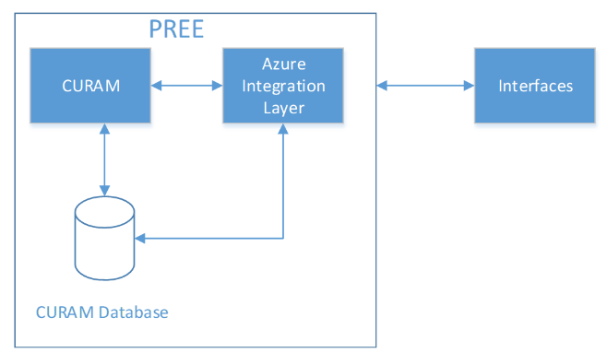
Figure 2: MEDITI3G Context Diagram
The following diagram provides a sampling of the MEDITI3G interfaces (formerly referred to as PREE). This figure is meant to provide some context into MEDITI3G’s interfaces; however, there are other required interfaces that are not fully referenced here, including federal and local interfaces.
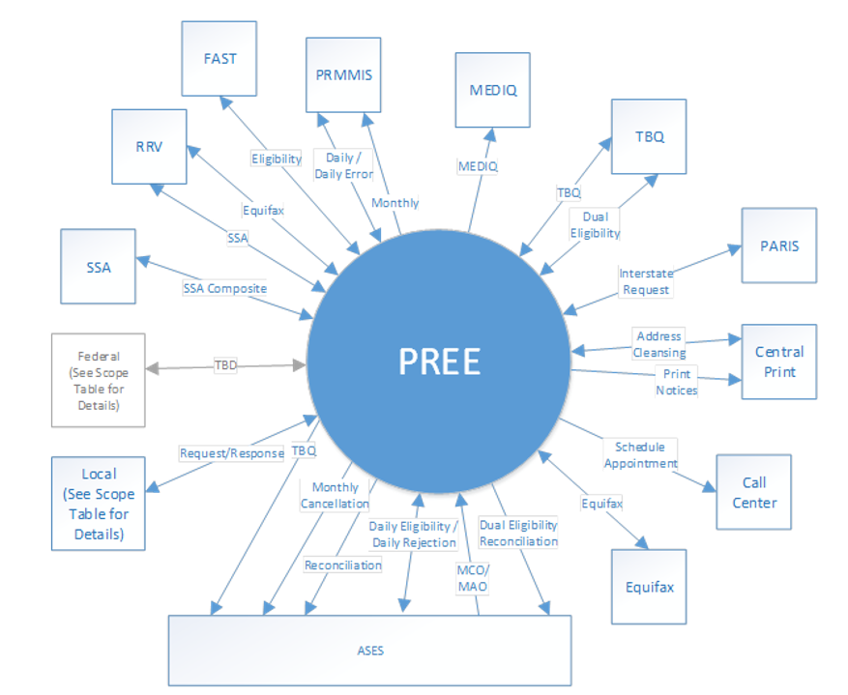

3. Requested Information
PRMP is in the process of planning for modernization across its MES and is seeking information from the vendor community to help provide recommendations that may be used to support planning activities and future procurements. PRMP owns and operates a certified E&E system with the support of its current E&E vendor, RedMane. PRMP is interested in exploring ways to modernize their current solution, including a potential future takeover of its existing E&E system. Respondents are encouraged to provide alternative recommendations they believe best align to PRMP’s needs, goals, and landscape, as well as national/industry trends.
The purpose of this RFI is to survey the market for the information requested herein and not to award a contract. Respondents should use Attachment A to respond to questions.
At a high-level, Attachment A includes the following questions/topics:
3.1 History of Respondent’s Support of Medicaid E&E Systems
3.2 General Business Experience Replacing or Taking Over a Medicaid E&E System
3.3 Managing the Project Schedule for the Replacement or Takeover of a Medicaid E&E System
3.4 Staffing Approaches for a Medicaid E&E System
3.5 Cost Estimates and Models for the Replacement or Takeover of a Medicaid E&E System
3.6 Documentation
3.7 Alternative Approaches
3.8 Anticipated Engagement and Potential Barriers
Please refer to Attachment A for further details and to document the Respondent’s response.

4. Timeline and Response Instructions
Sections 4.1 and 4.2 provide additional information regarding the timeline for response, response format, and PRMP contact information for Respondents. Should there be additional questions concerning the administration of this RFI, Respondents should contact PRMP’s solicitation coordinator, Elizabeth Otero Martinez, at elizabeth.otero@salud.pr.gov.

4.1 Timeline
The timeline for responding to the RFI is as follows:
Activity | Date
RFI Response Submission Deadline | 10/20/2023

4.2 Submission Requirements
All Respondents must send completed responses to all questions contained in Section 3, Requested Information, via email to the following contact at PRMP:
Name: Elizabeth Otero Martinez
Email address: elizabeth.otero@salud.pr.gov
Responses must be received on or before October 20, 2023. All Respondents must use the template contained in Attachment A of this RFI to submit their responses. PRMP will not mandate a page restriction; however, PRMP encourages respondents to be succinct and specific in their responses. Size 11 Arial font is preferred for submitted responses.
Any questions regarding the application process, deadline, and/or clarification of RFI questions should be directed to elizabeth.otero@salud.pr.gov prior to the response submission deadline of October 20, 2023.

5. Terms and Conditions
This RFI is issued solely for information and planning purposes and does not constitute a solicitation. Information about costs and pricing is submitted voluntarily and is non-binding on the Respondent. Responses to this RFI will not be considered legal offers nor will they result in an award of any type of contract.
PRMP is subject to strict accountability and reporting requirements as a recipient of funds from public sources. Any response or other information provided during a demonstration of a product, system or solution is subject to disclosure by PRMP as required by applicable law. The PRMP makes no agreements or representations of any kind, and expressly disclaims any requirement to maintain the confidentiality of any information provided in response to an invitation to demonstrate a product, system, or solution.
The PRMP reserves the right to copy any information provided by responding vendor organizations for the purposes of facilitating PRMP’s review of use of the information.
The PRMP reserves the right to use information or ideas that are provided by vendor organizations in the vendor’s response or product, system, or solution demonstration. By agreeing to demonstrate its product, system, or solution the vendor represents that such copying or use of information will not violate any copyrights, licenses, or other agreements with respect to information submitted or product, system or solution demonstrated.
The PRMP is not responsible for any costs incurred by a vendor organization for the development and provision of a response to this RFI.

